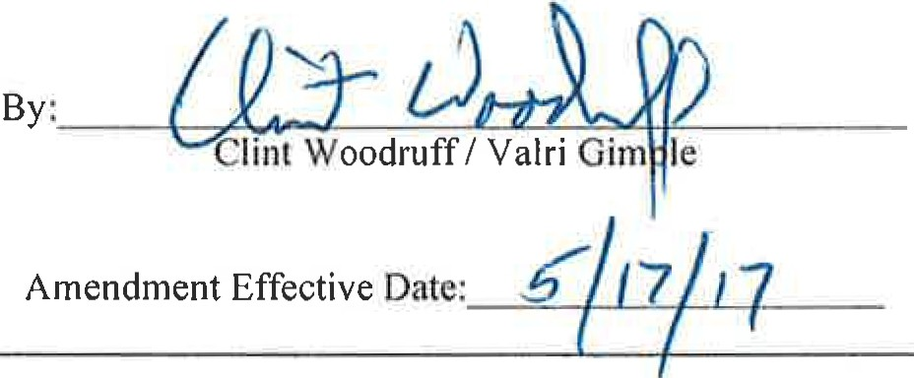

CONTRACT AMENDMENT #2

SIGNATURE AND COVER PAGE
State Agency  State of Colorado for the use & benefit of the Department of Human Services  Office of Early Childhood 1575 Sherman Street, I st Floor  Denver , CO 80203 | Original Contract Number  17 IHIA 89209
Contractor | Amendment Contract Number
Southern Colorado Developmental Disabilities Services, In c. | 17 IHIA 99057
PO BOX 781
Trinidad, CO 81082
Current Contract Maximum Amount | Contract Performance Beginning Date
Initial Term | July I, 2016
State Fiscal Year 2017 $57,965
Total for All State Fiscal Years $57,965 | Current Contract Expiration Date  June 30, 2017
THE PARTIES HERETO HAVE EXECUTED THIS AMENDMENT
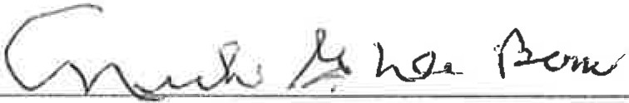
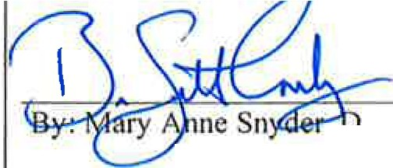Each person signing this Amendment represents and warrants that he or she is duly authorized to execute this Amendment and to bind the Part authorizin his or her si nature .
..C.Olff RACT O.R - --  Southern Colorado Developmental Disabilities Services, Inc . | STATE OF COLORADO  John W. Hicken looper, Governor Department of Human Services Reggie icha, Executive Director
By: Nick G. DeBono, Board President , irector, Office of Early Childhood
L. ( J-1 / ·z._o 1 7-
Date : - '-- - - - - - - - - - Date: 5_ 3'------ 1_7 _
In accordance with §24-30-202 C.R.S., this Amendment is not valid until signed and dated below by the State Controller or an
authorized de lega te.

STATE CONTROLLER
Robert Jaros, CPA, MBA, JD

- PARTIES
This Amendment (the "Amendment") to the Original Contract shown on the Signature and Cover Page for this Amendment (the "Contract") is entered into by and between the Contractor, and the State.
- TERMINOLOGY
Except as specifically modified by this Amendment, all terms used in this Amendment that are defined in the Contract shall be construed and interpreted in accordance with the Contract.
- AMENDMENT EFFECTIVE DATE AND TERM
  - Amendment Effective Date
This Amendment shall not be valid or enforceable until the Amendment Effective Date shown on the Signature and Cover Page for this Amendment. The State shall not be bound by any provision of this Amendment before that Amendment Effective Date, and shall have no obligation to pay Contractor for any Work performed or expense incurred under this Amendment either before or after of the Amendment term shown in §3.B of this Amendment.
  - Amendment Term
The Parties' respective performances under this Amendment and the changes to the Contract contained herein shall commence on the Amendment Effective Date shown on the Signature and Cover Page for this Amendment or April 17, 2017, whichever is later and shall terminate on the termination of the Contract.
- PURPOSE
Provide early intervention services to eligible infants, toddlers, and their families, which are provided in accordance with Section 27-10.5-701, C.R.S. and Rules and Regulations 12 CCR 2509-10, Sections 7.900-7.994, as currently exist or may hereafter be promulgated or amended, and federal regulations, 34 C.F.R., Part 303, Early Intervention Program for Infants and Toddlers with Disabilities. This amendment decreases the contract total for FYI 7 by $15,015, updates Exhibit F and removes Exhibit B.
- MODIFICATIONS
The Contract and all prior amendments thereto, if any, are modified as follows:
  - Decrease Contract Maximum Amount by $15,015 from $72,980 to $57,965
The Contract Maximum Amount table on the Contract's Signature and Cover Page is hereby deleted and replaced with the Current Contract Maximum Amount table shown on the Signature and Cover Page for this Amendment.
  - Exhibit B - Budget Allocation Spreadsheet
Exhibit B - is hereby removed from the original contract.

  - Exhibit F - Budget
Exhibit F - Amendment #2, which is attached and incorporated into this Amendment, replaces Exhibit F.

6. LIMITS OF EFFECT AND ORDER OF PRECEDENCE
This Amendment is incorporated by reference into the Contract, and the Contract and all prior amendments or other modifications to the Contract, if any, remain in full force and effect except as specifically modified in this Amendment. Except for the Special Provisions contained in the Contract, in the event of any conflict, inconsistency, variance, or contradiction between the provisions of this Amendment and any of the provisions of the Contract or any prior modification to the Contract, the provisions of this Amendment shall in all respects supersede, govern, and control. The provisions of this Amendment shall only supersede, govern, and control over the Special Provisions contained in the Contract to the extent that this Amendment specifically modifies those Special Provisions.

Exhibit F - Amendment #2

Colorado Department of Human Services Office of Early Childhood
BUDGET WITH JUSTIFICATION FORM
Contractor Name | Southern Colorado Developmental Disabilities Services, Inc.
Budget Period | July 2016-June 2017
Project Name | Early Intervention

Program Contact Name, Title, Phone and Email | Duane Roy, CEO 719-846-4409  droy@scds.com
Fiscal Contact Name, Title, Phone and Email | Mary Beach, CFO 719-846-3391 X 101  marybeach@scdds.com

Expenditure Categories
State General Funds Service Coordination | FY 2017
Description of Work | Funding Amount
Paid as fixed price at rate of 1/12 per month. Provide Service Coordination activities including working with families from initial referral through evaluation; to ensure the IFSP is completed; help navigate the system for early intervention services for the duration of the open case file; specific details for service coordination can be found in Exhibits A and B. | $9.485
State General Fund - Direct Services | FY 2017
Description of Work | Funding Amount
Paid as fee for service. The Early Intervention Program shall design services to meet the developmental needs of an eligible infant or toddler and the needs of his .or her family related to functional outcomes to enhance the child's development in the domains of adaptive development, cognitive development, communication development, physical development (including vision and hearing), and, social emotional development. Direct Services include, not limited to, speech therapist, occupational therapist, mental health consultation, other  disciplines that work directly with the client as defined in Exhibits A and B. | $30,610
State General Fund - Operations | FY 2017
Description of Work | Funding Amount
Paid as fixed price at rate of 1/12 per month for infrastructure, administration and other services as defined in Exhibits A & B. | $2,987
State General Fund - Indirect (10%) | FY 2017
Description of Work | Funding Amount
Indirect costs calculated at 10% of total direct costs. | $4,308
Federal Part C Funds - Direct Services | FY 2017
Description of Work | Funding Amount
Paid as fee for service. The Early Intervention Program shall design services to meet the developmental needs of an eligible infant or toddler and the needs of his or her family related to functional outcomes to enhance the child's development in the domains of adaptive development, cognitive development, communication development, physical development (including vision and hearing), and, social emotional development. Direct Services include, not limited to, speech therapist, occupational therapist, mental health consultation, other  disciplines that work directly with the client as defined in Exhibits A and B. | $4,426
Federal Part C Funds - Operations | FY 2017
Description of Work | Funding Amount
Paid as fixed price at rate of 1/12 per month for infrastructure, administration and other services as defined in Exhibits A & B. | $1.586
Federal Part C Funds- Indirect (10%) | FY 2017
Description of Work | Funding Amount
Indirect costs calculated at 10% of total direct costs. | $826
Federal Part C Funds Carry Forward- Indirect (10%) | FY 2017
Description of Work | Funding Amount
Indirect costs calculated at 10% of total direct costs. | $136
Federal Part C Funds - Service Coordination | FY 2017
Description of Work | Funding Amount
Paid as fixed price at rate of 1/12 per month. Provide Service Coordination activities including working with families from initial referral through evaluation; to ensure the IFSP is completed; help navigate the system for early intervention services for the duration of the open case file; specific details for service coordination can be found in Exhibits A and B. | $1,251
Federal Part C Funds Carry Forward - Service Coordination | FY 2017
Description of Work | Funding Amount
Paid as fixed price at rate of 1/12 per month. Provide Service Coordination activities including working with families from initial referral  through evaluation; to ensure the IFSP is completed; help navigate the system for early intervention services for the duration of the open case file; specific details for service coordination can be found in Exhibits A and B. | $1,227

Exhibit F - Amendment #2

Federal Part C Funds - Referred Evaluated Not Eligible (RENE) |  | FY 2017
Description of Work |  | Funding Amount
Paid as fixed price. Reimbursement for costs related to evaluation services for eligibil ity determination for infant s, toddlers or families referred for early intervention services that are determined not eligible. |  | $1,123
I | 'fOTAL | $57,965
*Figures are rounded using basic accounting standards. (0.00-0.49 = O; 0.50-0.99=1 .0)

