CONTRACT AMENDMENT #1

SIGNATURE AND COVER PAGE
State Agency  State of Colorado for the use & benefit of the Department of Human Services  Office of Early Childhood 1575 Sherman Street, 1•t Floor  Denver CO 80203 |  | Original Contract Number  17 IHIA 89209
Contractor |  | Amendment Contract Number
Southern Colorado Developmental Disabilities Services, Inc. |  | 17 IHIA 96852
PO BOX781
Trinidad, CO 81082
Current Contract Maximum Amount |  | Contract Performance Beginning Date
Initial Term |  | The later of the Effective Date or July 1, 2016
State Fiscal Year 2017 | $72,980
Extension Terms |  | Current Contract Expiration Date  June30,2017
State Fiscal Year 20xx | $0.00
Total for All State Fiscal Years | $72,980
THE PARTIES HERETO HAVE EXECUTED THIS AMENDMENT
Each person signing this Amendment represents and warrants that he or she is duly authorized to execute this Amendment
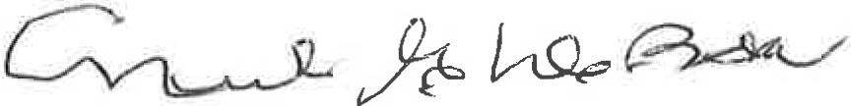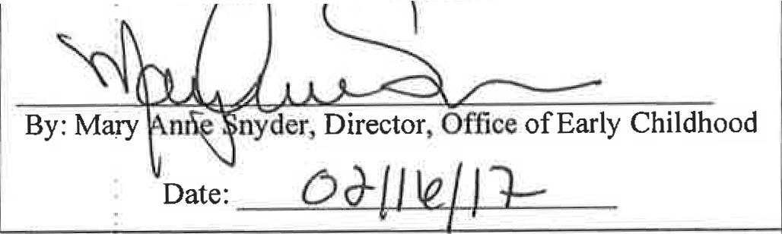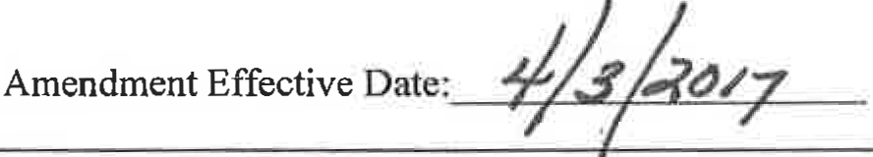 and to bind the Pa authorizin his pr her si nature.
CONTRACTOR
Southern Colorado Develup1mmtal Disabilities Services, Inc.
STATE OF COLORADO
John W. Hickenlooper, Governor De ·tment of Human Services Re i Bic , Ex outive Director
By: Nick G. DeBono, Board President

Date:- - - - - - - - - - -
In accordance with §24-30-202 C.R.S., this Amendment is not valid until 'signed and dated below by the State Controller or an
authorized delegate.

STATE CONTROLL}j':R
Robert Jaros, CPA, MBt, JD
By:-----
-'L.. -+ ,•d ,_:: _.....)
Clint Woodru ple

- PARTIES
This Amendment (the "Amendment") to the Original Contract shown on the Signature and Cover Page for this Amendment (the "Contract") is entered into by and between the Contractor, and the State.
- TERMINOLOGY
Except as specifically modified by this Amendment, all terms used in this Amendment that are defined in the Contract shall be construed and interpreted in accordance with the Contract.
- AMENDMENT EFFECTIVE DATE AND TERM
  - Amendment Effective Date
This Amendment shall not be valid or enforceable until the Amendment Effective Date shown on the Signature and Cover Page for this Amendment. The State shall not be bound by any provision of this Amendment before that Amendment Effective Date, and shall have no obligation to pay Contractor for any Work performed or expense incurred under this Amendment either before or after of the Amendment term shown in §3.B of this Amendment.
  - Amendment Term
The Parties' respective performances under this Amendment and the changes to the Contract contained herein shall commence on the Amendment Effective Date shown on the Signature and Cover Page for this Amendment or January 1, 2017 and shall terminate on the termination of the Contract.
- PURPOSE
Provide early intervention services to eligible infants, toddlers, and their families, which are provided in accordance with Section 27-10.5-701, C.R.S. and Rules and Regulations 12 CCR 2509-10, Sections 7.900-7.994, as currently exist or may hereafter be promulgated or amended, and federal regulations, 34 C.F.R., Part 303, Early Intervention Program for Infants and Toddlers with Disabilities. This amendment increases the contract total for FYl 7 by $1, updates Exhibits B, F and H and adds Exhibit I.
- MODIFICATIONS
The Contract and all prior amendments thereto, if any, are modified as follows:
  - The "Contract Price Not to Exceed" and the "Maximum Amount Available Per Fiscal Year" of $72,979 is increased by $1 for a new "Contract Price Not to Exceed" and the "Maximum Amount Available Per Fiscal Year" amount of $72,980. The Contract Maximum Amount table on the Contract's Signature and Cover Page of this Amendment hereby replaces the table on Page 1 of the Contract.
  - Exhibit B - Budget Allocation Spreadsheet
Exhibit B - Amendment #1, which is attached and incorporated into this Amendment, replaces Exhibit B.
  - Exhibit F - Budget
Exhibit F - Amendment #1, which is attached and incorporated into this Amendment, replaces Exhibit F.

Exhibit H- Supplemental Provisions for Federal Awards
Exhibit H - Amendment #1, which is attached and incorporated into this Amendment, replaces Exhibit H.

Exhibit I - Additional Provisions

Exhibit I, which is attached and incorporated into this Amendment, 1s added to the Contract.
- LIMITS OF EFFECT AND ORDER OF PRECEDENCE
This Amendment is incorporated by reference into the Contract, and the Contract and all prior amendments or other modifications to the Contract, if any, remain in full force and effect except as specifically modified in this Amendment. Except for the Special Provisions contained in the Contract in the event of any conflict, inconsistency, variance, or contradiction between the provisions of this Amendment and any of the provisions of the Contract or any prior modification to the Contract, the provisions of this Amendment shall in all respects supersede, govern, and control. The provisions of this Amendment shall only supersede, govern, and control over the Special Provisions contained in the Contract to the extent that this Amendment specifically modifies those Special Provisions.

FY 2016-17 Budget Allocation REVISED Exhibit B - Amendment #1

 | A | B C D E F G |  |  | H M
 | Report Period Update | Historical Average Monthly Enrollment |  |  | FY 15-16 Average Monthly Enrollments {AME)  Projections
2 1 | 7/1/,:4 6/}Q1lS | Source: | Report  !Period:
3

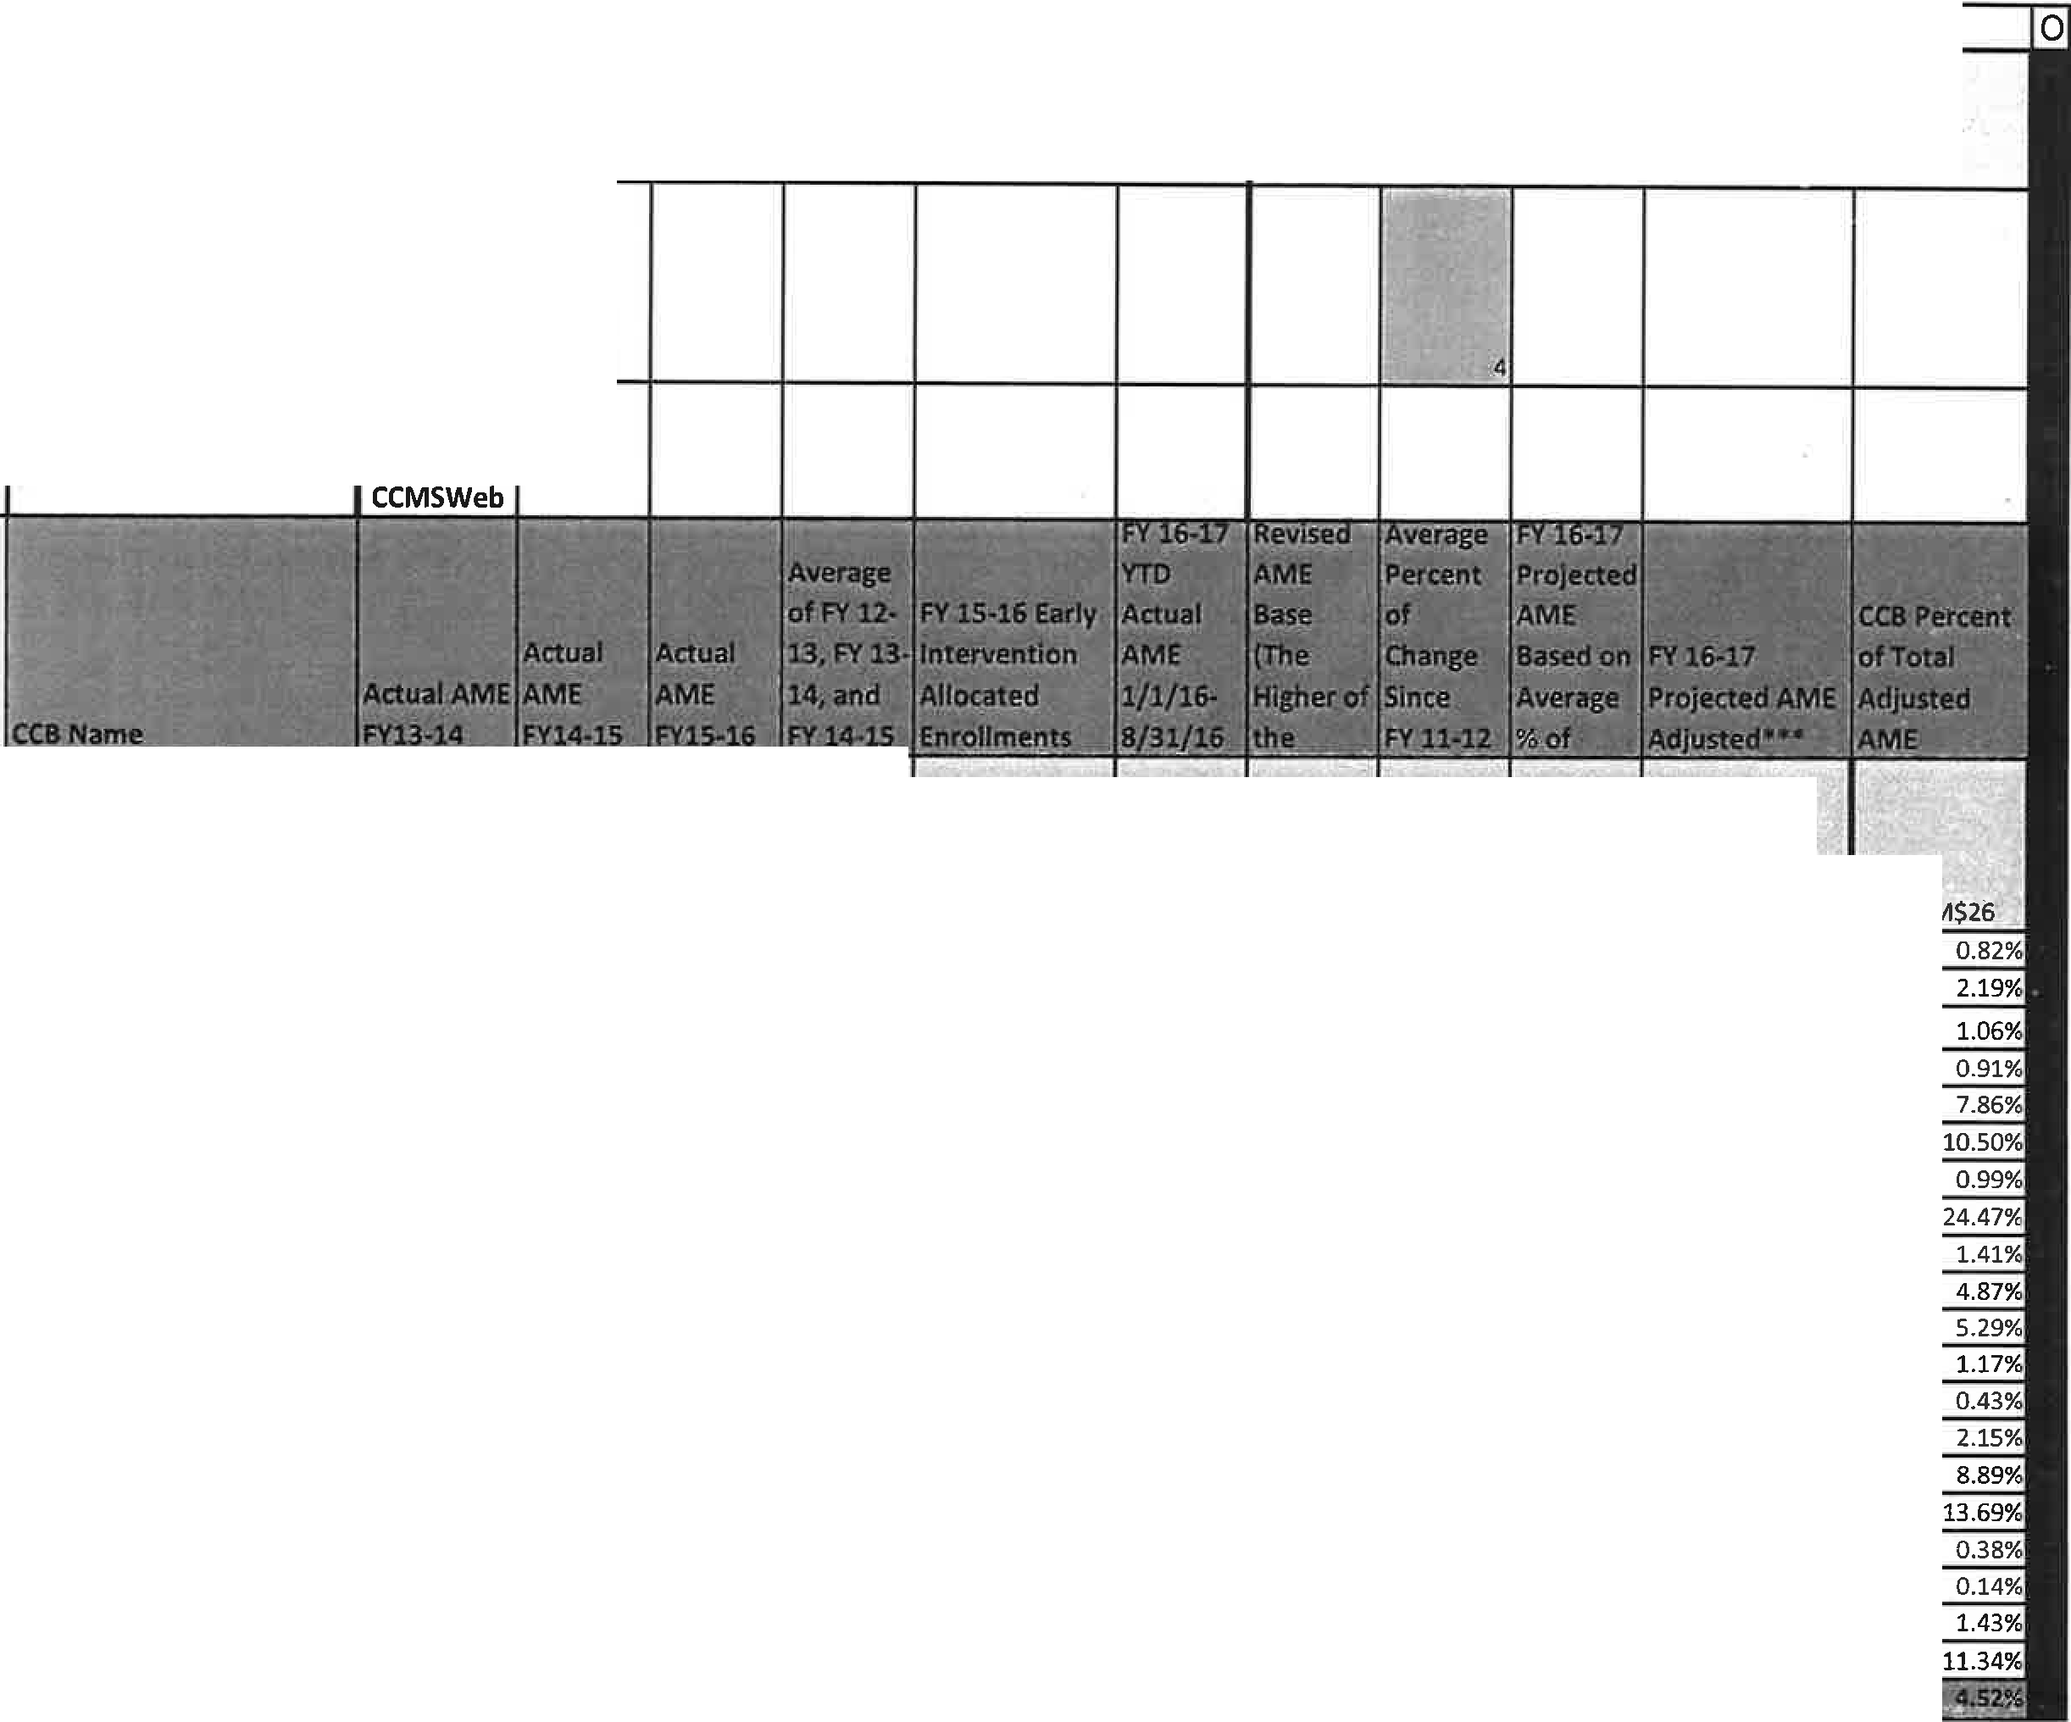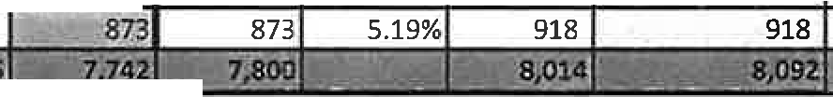I l,
4 -,-r;;;;;;;;;c
:a,-c · _r· r -cl

ROU N D(( (G6- =ROl.JND((
86 6 0 6 fF(G6<:E6, B6)/B6/$1$ G6*I6)+G6
5 !Formulas )/3,0i E6;Gf5) . 2 . ,0) :=Jf.(J&<fl6,H6';16) _ =M6/$M$26 BLUE PEAKS 57 55 65 59 57 64 64 3,07% 66 66
7 COLORADO BLUESKY 162 182 173 172 201 l'l 174 1.85% 177
8 COMMUNITY CONNECTIONS 56 60 74 63 68 78 78 9.82% 86
9 COMMUNITY OPTIONS 68 62 69 66 94 7,3 73 1.84% 74 7
10 ODC/IMAGINE! 518 550 602 557 571 fi()j 609 4.39% 636 636
11 DEV. DISAB. RES. CTR 580 658 773 670 696 ?,S,-2 78? 8.71% 850 850
12 DEV. OPP/STARPOINT 68 62 74 68 68 7fJ 77 3.31% 80 80
13 DEV. PATHWAYS 1,626 1,784 1,892 1,767 1,912 f.lfijffi) 1,900 4.21% 1,980 1, 980
14 EASTERN 100 107 106 104 113 111 2.75% 114 114
15 ENVISION 342 367 373 361 397 83 383 3.00% 394 394
16 FOOTHILLS-GATEWAY 357 375 402 378 410 4.12 412 3.85% 428 428
17 HORIZONS 56 71 82 70 80 @ 84 12.50% 95 95
18 INSPIRATION FIELD 23 28 34 28 30 3,? 32 9.78% 35 35
19 MOUNTAIN VALLEY 161 162 172 165 166 L 171 171 1.55% 174 174
20 NORTH METRO 734 751 673 719 838 p_88 719 -1.57% 677 719
21 RMHS 1,112 1,123 1,088 1,108 1,141 U9o 1,103 -0.49% 1,085 1,108
22 SOUTHEASTERN 11 15 25 17 20 .24 24 29.55% 31 31
23 SOUTHERN CO DEV SERV 7 11 9 9 13 l.0 1D 10.71% 11 11
STRIVl 124 118 105 116 122 1,1/)7 115 -3.43% 103 116
25 TRE 723 802 860 795 838

6 ; !!. -· -u,•.J& -- --.111 i 1-r , ··
0
:?..,.. C -.=_·--... , -

C
-.

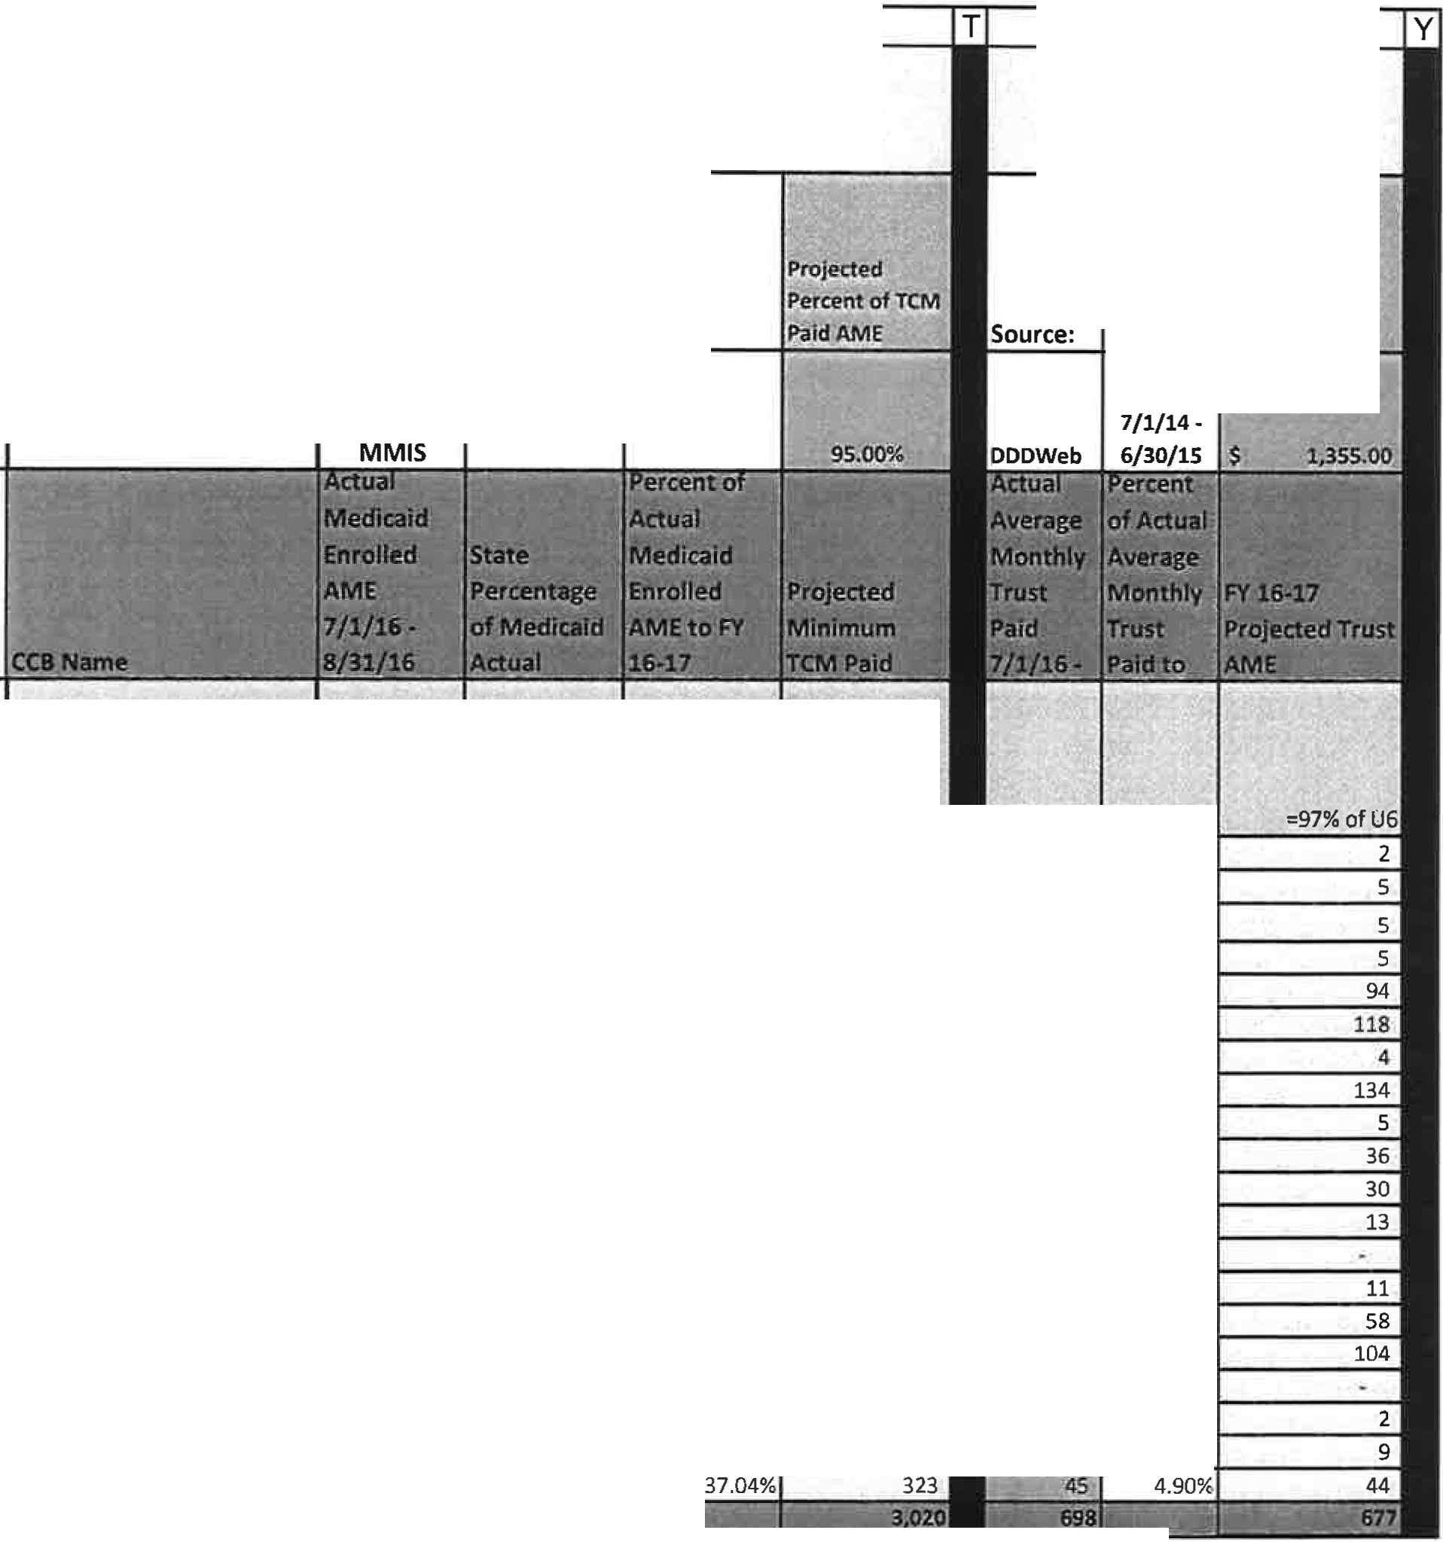FY 2016-17 Budget Allocation REVISED Exhibit B - Amendment #1
A
p
Q
R
s
u V w
Report Period Update
Targeted Case Management
Insurance Trust Fund
2 17/1/14 · 6/30/15
Source :
Report
Period:
3
4
5
6
7
8
9
f ormulas
l3LUE PEAKS
..
'
- -
COLORADO BLUESKY
COMMUNITY CONNECTIONS COMMUNITY OPTIONS
10 DOC/IMAGINE!
1 DEV. DISAB. RES. CTR
- DEV. OPP/STARPOINT
- DEV. PATHWAYS
- EASTERN
- ENVISION
- FOOTHILLS-GATEWAY
- HORIZONS
- INSPIRATION FIELD
- MOUNTAIN VALLEY
- NORTH METRO
- RMHS
43
112
3.7
42
'207
-1252
k¾
<t%
1
1-%
1%
8
-1%
!Z
2%
5%.
5%
1$
=P6/M6
65.15%
66.10%
43.02%
56.76%
32.55%
30.82%
55.00%
34.65%
44.74%
43.65%
39.95%
33.68%
68.57%
36.21%
51.18%
38.90%
61.29%
:=ROUND($S$3• P6,0)
41
111
35
40
197
249
42
652
48
163
162
30
23
60
350
409
I
,r --.. -
1 --
!Z

s
I
s
i-
I
"
,.
I
-
-
68tl
S1_
1n
17il
32
24 ,
. 3
'3 8
43
-
-
.._,
I
·-·
1.1¼,
' ,
-
,:.,, ...
-
:1j
_,.
I
l'2%
14%
"
-
.
97'
122c
4
:138'
5
:17
M
13
0
1,1.
' 6Q;
.10-7.
=U6/M6
3.03%
2.82%
5.81%
6.76%
15.25%
14.35%
5.00%
6.97%
4.39%
9.39%
7.24%
13.68%
0.00¾
6.32¾
8.34%
9.66%
10• ===
.....
0.00%
6
18.18%
7.76%
26 I • .....,- •U>--::..: llilfefOl'llllliWIP•l wr12 • - sir
0
I n=J I .

 | Report Period: | lllSU_!j111be Trust  F!lnlf Service  C0Qrdln2tion  !Rate Per  .Enroll,; ent

-
--

22 | SOUTHEASTERN Ii |  | l9 |  |  | 18 | ..- | (j
23 | SOUTHERN co' DEV SERV |  | '6 | 0% | 54.55%
24 | STRIVE |  | 64 | 2% | 55.17% | 61 | - - | ij

FY 2016-17 Budget Allocation REVISED Exhibit B -Amendment #1

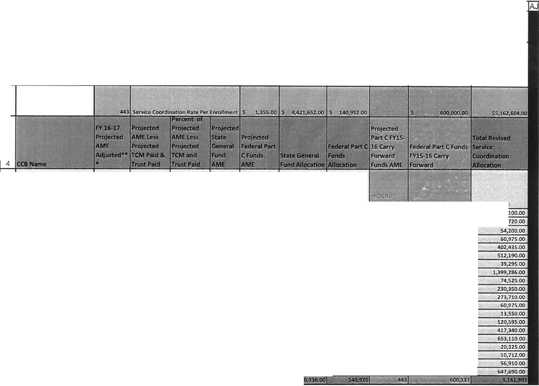A z AA AB AC AD AE AF AG AH Al

Report Period Update
Service Coordination

2 17/1/14. 6/30/15
Maximum # enrollment that can be reimbursed through
State General Fund 3,263

State General
t041Fund
Service Coordination Total Funds

3

=ROUND($
AC$2•AB6, =ROUND($AD$
5 Formulas =M6 =M6-S6-W6 =AA6/$AA$26 0) 2• AB6, 0) =$AD$3*AC6 =$AD$3.AD6 (SZ$3*AB6,0)

:..•

,-_.
=AE6+AF6+AH6

6 BLUE PEAKS 66 23 0.52% 17 1 $ 23,035.00 $ 1,355.00 2 .L - ..
2,710.00 , $ 27,100.01

7 COLORADO BLUESKY 177 61 1.39% 52 1 $ 70,460.00 $ 1,355.00 ·.' l! :$ •. .. · . 14;905,00 $ • 86,720.00
8 COMMUNITY CONNECTIONS 86 46 1.05% 34 1 $ 46,070.00 $ 1,355.00 •' .. 5 $ ., ·., . -; ,775,001 $
9 COMMUNITY OPTIONS 74 29 0.66% 41 1 $ 55,555.00 $ 1,355.00 . .. ;i s··........;.;40, 6.o,o . $
0 DDC/IMAGINE! 636 345 7.85% 254 8 $ 344,170.00 $ 10,840.00 , 35 , $ ...1· c',•·4 7.,425 :00 _ ,$
1 DEV. DISAB . RES. CTR 850 483 10.98% 321 11 $ 434,955.00 s 14 , 905.00 48 $· ,'. .. . ., l 62 ;330.00 $
12 DEV. OPP/STARPOINT 80 34 0.78% 25 1 $ 33,875.00 $ 1, 355.00 - 7 .3 s.-. ·- 4 ,065.00 · $
13 DEV. PATHWAYS 1,9 80 1,194 27.17% 887 28 $ 1,201 ,4 56.00 $ 37,940 .00 ·. . 118 ,$ •, ."1 59 , 890 . 00 $
14 EASTERN 114 61 1.39% 45 1 $ 60,975.00 $ 1,355.00 - .. 9 $ ' ;. ,12 195:00 $
15 ENVISION 394 195 4.44% 145 5 $ 196,475.00 $ 6,775.00 . - - 20 $ t• , ·· , .•·.·27 JOO.OD $

16 FOOTHILLS-GATEWAY 428 236 5.37% 175 6 $ 237,125.00 $ 8,130.00 -··-
21 $.. · - , 281 4 55.00 $

17 HORIZONS 95 52 1.19% 39 1 $ 52, 845.00 $ 1, 355.00
18 INSPIR ATION FIELD 35 12 0.27% 9 0 $ 12,195.00 $ .
. ,_ ,5 ,•$ , ...... , • 6,77 5,00 . $
. l ·$·=· ··>. -_ ·,_ 1,3 55.00 $
- .

19 MOUNTAIN VALLEY 174 103 2.35% 77 2 $ 104,335.00 $ 2,710.00 .: ... :::10 '$"- <· .:. .113 550.00 · $
20 NORTH METRO 719 311 7.07% 242 7 $ 327,910.00 $ 9,485.00 -- · ' .5;i ·$, ·:: .·,·· 79 ,945.00 $

21 RMHS 1,108 595 13.54% 437 14 $ 592, 135.00 $ 18, 970.00 -.
31 $ C :.:,,i ,,·, a\•"4 2,005,QQ $

22 SOUTHEASTERN 31 13 0.30% 12 2 $ 16,260.00 $ 2,710.00 ·,_. • r ·: .·' , 1 . S - ··. ·,. · ,1 1_:355.00 s
23 SOUTHERN CO DEV SERV 11 3 0.07% 7 0 $ 9,485.00 $ . : 1 $ ;_. 1; 2 21.00 . $
24 STRIVE 116 46 1.05% 35 1 $ 47,4 25.00 $ 1,355.00 .. :6 $; ,_. • ,;:.:8,130 .00 1 $
25 TRE 918 551 12.55% 409 13 $ 554,195.00 $ 17,615.00 •-,-: _,..55 ,$ it,,:/J.• -:., ., . 75, 880.00 $
26 ' • " •.· I . ,f O! 8,092 illri,:&.li:::J 95 ..,,.,.100% liiila3r263 -41 itq

FY 2016-17 Budget Allocation REVISED Exhibit B - Amendment #1
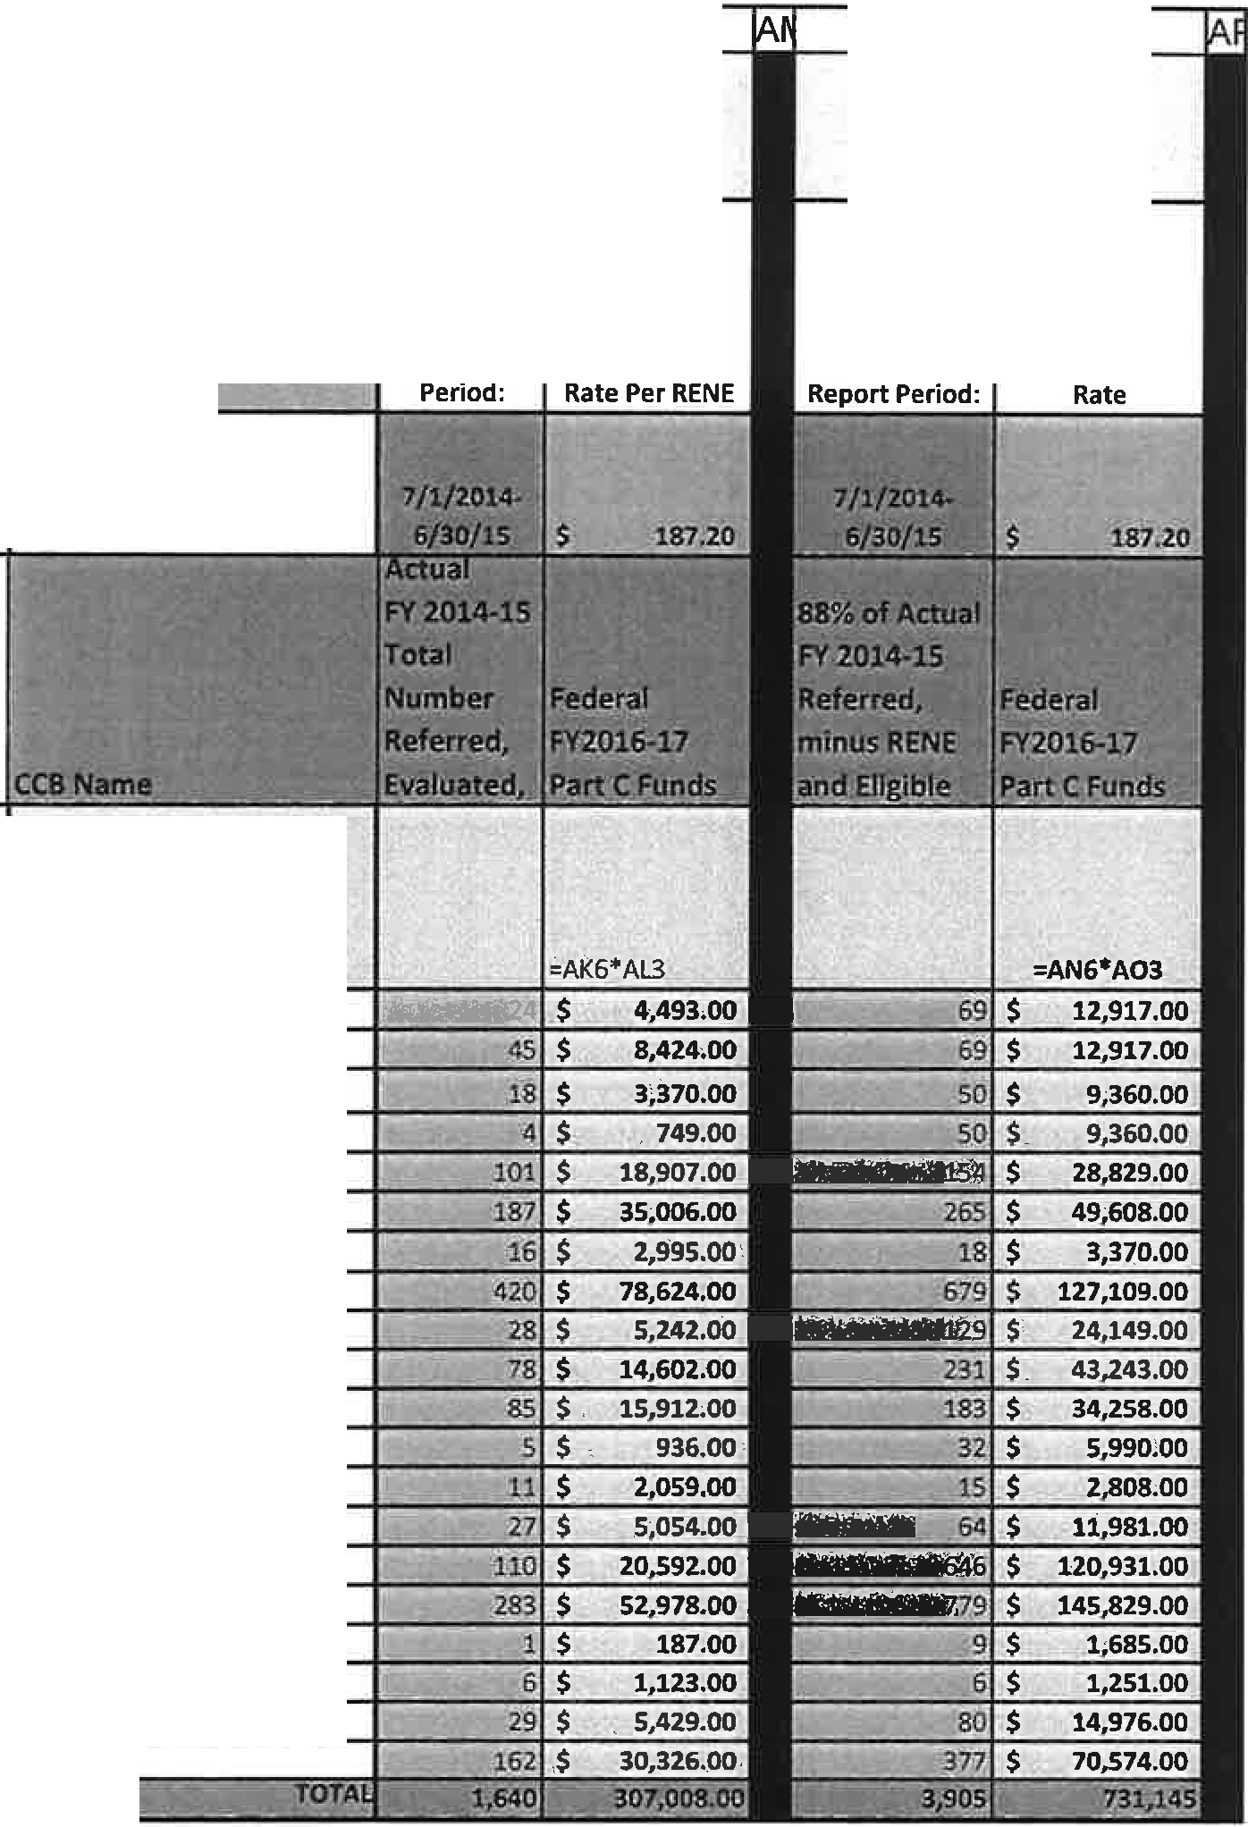
AK
AL
AN AO
Referred, Evaluated,
Not Eligible (RENE) Unreimbursed Costs
Report
2 IUl/1'4 - 6/ otl5
3
4
5 Formulas
BLUE PEAKS
COLORADO BLUESKY
DEV. PATHWAYS EASTER ENVISION
FOOTHILLS-GATEWAY HORIZONS
18 INSPIRATION FIELD
25IBE
26
A

Report Period Update
6
7
8
COMMUNITY CONNECTIONS
9
COMMUNITY OPTIONS
10
DOC/IMAGINE!
11
DEV. DISAB. RES. CTR
2
DEV. OPP/STARPOINT
3
4
15
16
17
MOUNTAIN VALLEY
20
NORTH METRO
21
RMHS SOUTHEASTERN
22
23
SOUTHERN CO DEV SERV STRIVE
24

FY 2016-17 Budget Allocation REVISED Exhibit B - Amendment #1

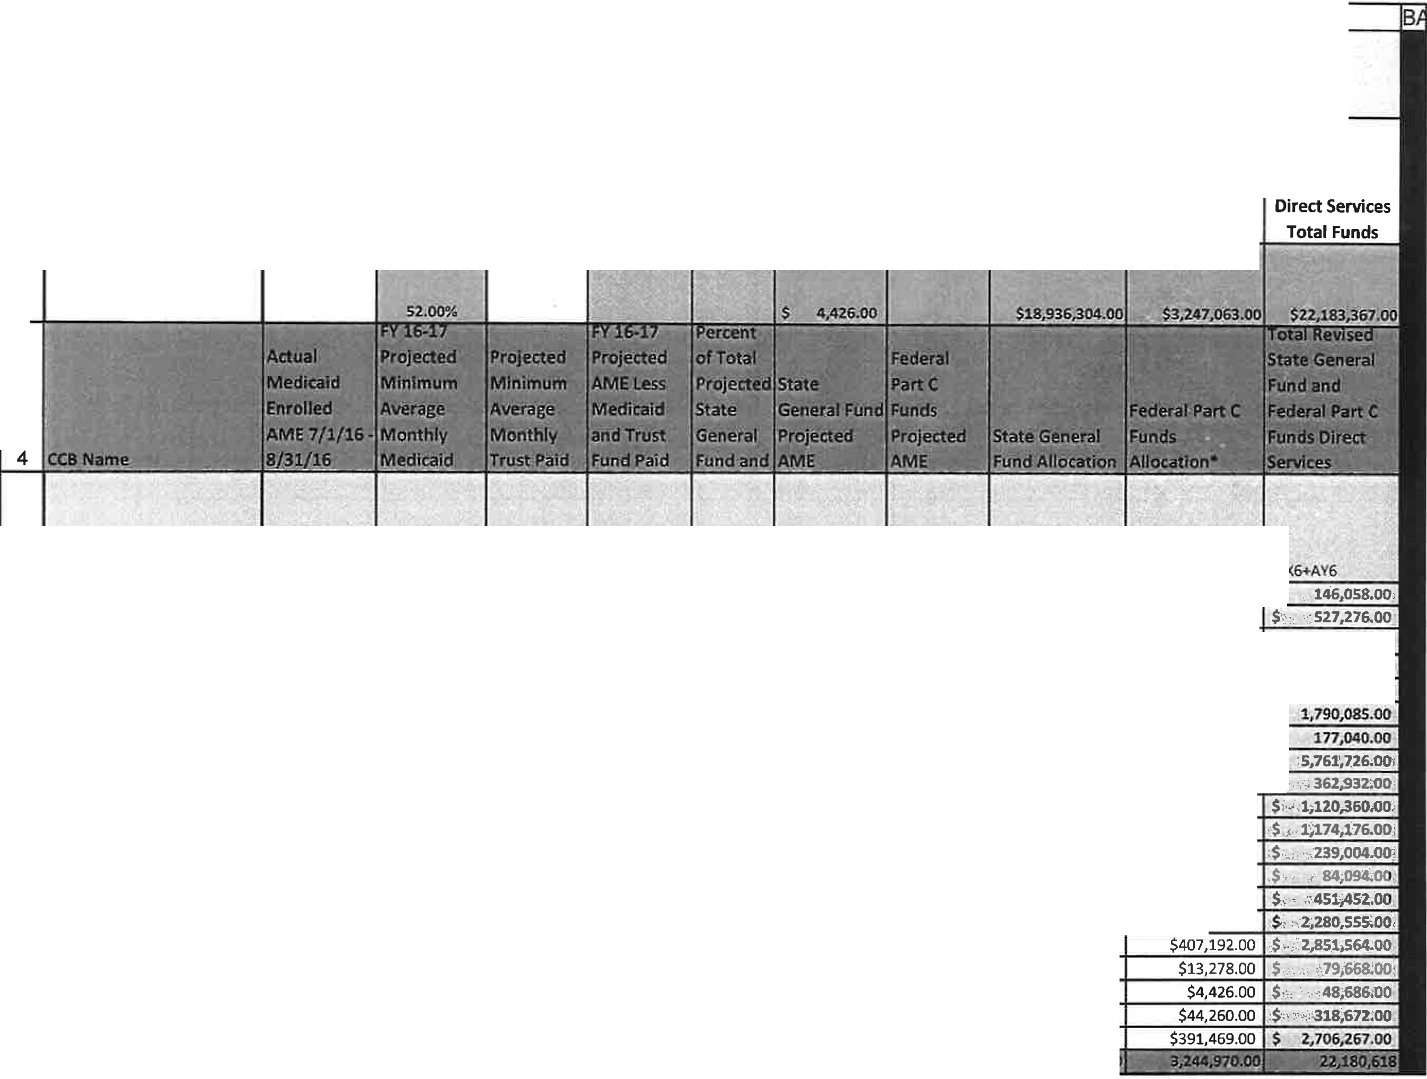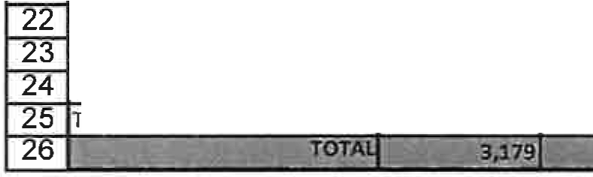A AQ AR AS AT AU AV AW AX AY AZ

Report Period Update
Direct Services

2 17/1/14 • 6{30/1S

Projected
Pe ent.A¥ E Medicaid State P.lan
:l!nrollment that ca;\ be relmti\ltsed ffirough State
G'ener;il Fun'tt 4, 781

FY 2016-17
State General 7.341F und

FY 2016-17
Federal Part C
Funds

3

=ROUND(AQ6 =ROUND(M6- =AT6/ $AT$
5 Forinulas =P6 0 $ R$3,0} =W6 AR6-AS6,0 ) 26 -=AV2'4 AU6 ·=. AW2 AU6 =AV6•$AV$3 =$AV$3• AW6 l=AX6+AY6
6 BLUE PEAKS 43 22 2 33 0.58% 25 4 $123,928.00 $22,130.00 $,,
7 COLORADO BLUESKY 117 61 5 111 1.97% 84 14 $451,452.00 $75,824.00
8 COMMUNITY CONNECTIONS 37 19 5 45 0.80% 34 6 $172,614.0.0 $26,556.00 $,· ·: 199;170.00'
9 COMMUNITY OPTIONS 42 22 5 47 0.83% 36 6 $230,152.00 $39,834.00 ,$., ,.,,c.269,986.00 ,
10 DOC/IMAGINE! 207 108 94 358 6.34% 271 47 $1,358,782.00 $233,065.00 $.,;. l;S91;847,00.'
11 DEV. DISAB. RES. CTR 262 136 118 596 10.56% 452 78 $1,531,396.00 $258,689.00 $
 | PP/STARPOI NT | 44 | 23 | 4 | 40 | 0.71% | 30 | 5 | $150,484.00 | $26,556.00 | $
13 | DEV. PATHWAYS | 686 | 357 | 134 | 1, 489 | 26.39% | 1129 | 194 | $4,917,286.00 | $844,440.00 | ,$::
14 | EASTERN | 51 | 27 | 5 | 82 | 1.45% | 62 | 11 | $300,968.00 | $61,964.00 | $':
15 | ENVISION | 172 | 89 | 36 | 269 | 4.77% | 204 | 35 | $960,442.00 | $159,918.00
16 | FOOTHILLS-GATEWAY | 171 | 89 | 30 | 309 | 5.48% | 234 | 40 | $991,424.00 | $182,752.00
17 | HORIZONS | 32 | 17 | 13 | 65 | 1.15% | 49 | 8 | $199,170.00 | $39,834.0(
18 | INSPIRATION FIELD | 24 | 12 | 0 | 23 | 0.41% | 17 | 3 | $66,390.00 | $17,704.00
19 | MOUNTAIN VALLEY | 63 | 33 | 11 | 130 | 2.30% | 99 | 17 | $385,062.00 | $66,390.00
20 | NORTH METRO | 368 | 191 | 58 | 470 | 8.33% | 356 | 61 | $1,951,866.00 | $328,689.00
21 | RMHS | 431 | 224 | 104 | 780 | 13.82% | 591 | 101 | $2,444,372.00
 | SOUTHEASTERN | 19 | 10 | 0 | 17 | 0.30% | 13 | 2 | $66,390.00
 | SOUTHERN CO DEV SERV | 6 | 3 | 2 | 10 | 0.18% | 8 | 1 | $44,260.00
 | STRIVE | 64 | 33 | 9 | 72 | 1.28% | 56 | 10 | $274,412.00
 | RE | 340 | 177 | 44 | 697 | 12.35% | 528 | 91 | $2,314,798.00

FY 2016-17 Budget Allocation REVISED Exhibit B -Amendment #1
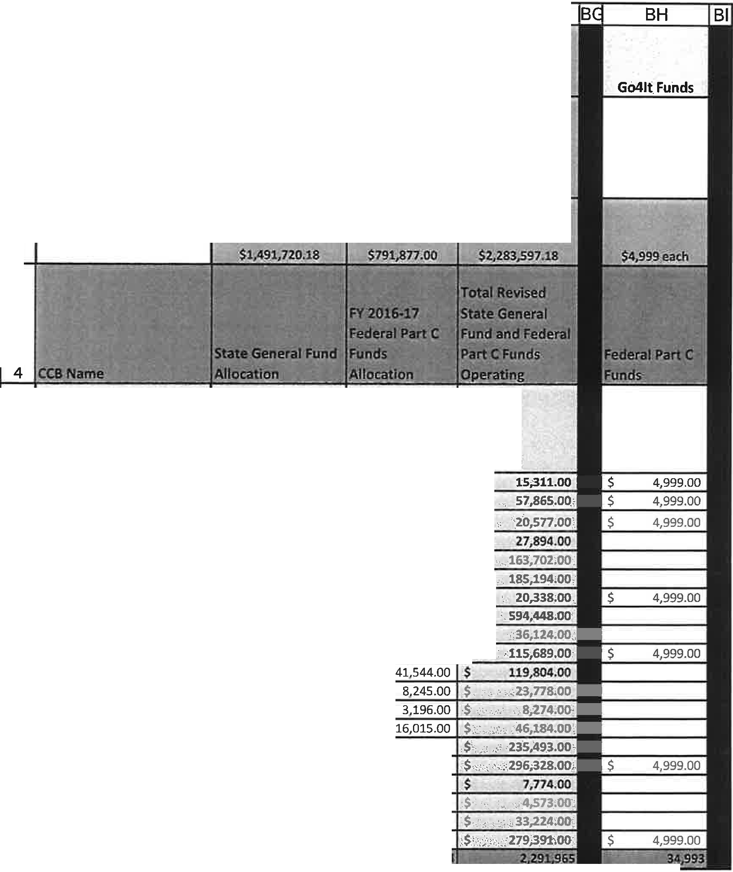
A
BB
BO
BE
Report Period Update
Operating
1 "$90'6:00
2 17/1/3:4. : 6/30/!_S.
FY 2016-17
FY 2016-17 State Federal Part C
General Fund Funds To,tal .Op'e,ratlQg:
3
5 !Formulas
BLUE PEAKS COLORADO BLUESKY
COMMUNITY CONNECTIONS
COMMUNITY OPTIONS
25 TRE
2o
.:BB3•AU6
$
$
$
$
$
$
$
$
$
$
$
$
$
$
$
$
$
$
$
$
=$B0$3..AU6
9,857.00
35,546.00
13,442.00
18,221.00
106, 935.00
120,975.00
11,948.00
388,313.00
23,597.00
75,572.00
78 ,260.00 lS,533.00 5,078.00
30,169.00
153,832.00
192,364.00
5,078.00
2,987.00
21,507.00
182,507.00
$
$
$
$
$
$
s
$
$
$
$
$
$
$
$
$
$
$
$
$
bi i,;.•
5,454.00
,,iBB6+8D6
$
7
22,319.00 $
7,135.00 $'•:'
9,673.00
- DOC/IMAGINE!
- DEV. DISAB. RES. CTR
- DEV. OPP/STARPOINT
- DEV. PATHWAYS
- EASTERN
56,767.00
64,219.00 I s ,..
8, 390.00
206,135.00
12,527.00
40,117.00
$,
$
$
,.
- ENVISION
- FOOTHILLS-GATEWAY
- HORIZONS
- INSPIRATION FIELD
- MOUNTAIN VALLEY
- NORTH METRO
- RMHS
- SOUTHEASTERN
- SOUTHERN CO DEV SERV
- STRIVE
81,661.00
103,964.00
2,696.00
1,586.00
11,717.00
96,884.00
·- -- _•· ! ..,,,.;i.•7!T. .<>J". -' . -:.:i.i_- - - "1.\0tt
-
-
.... ......

FY 2016-17 Budget Allocation REVISED Exhibit B - Amendment #1

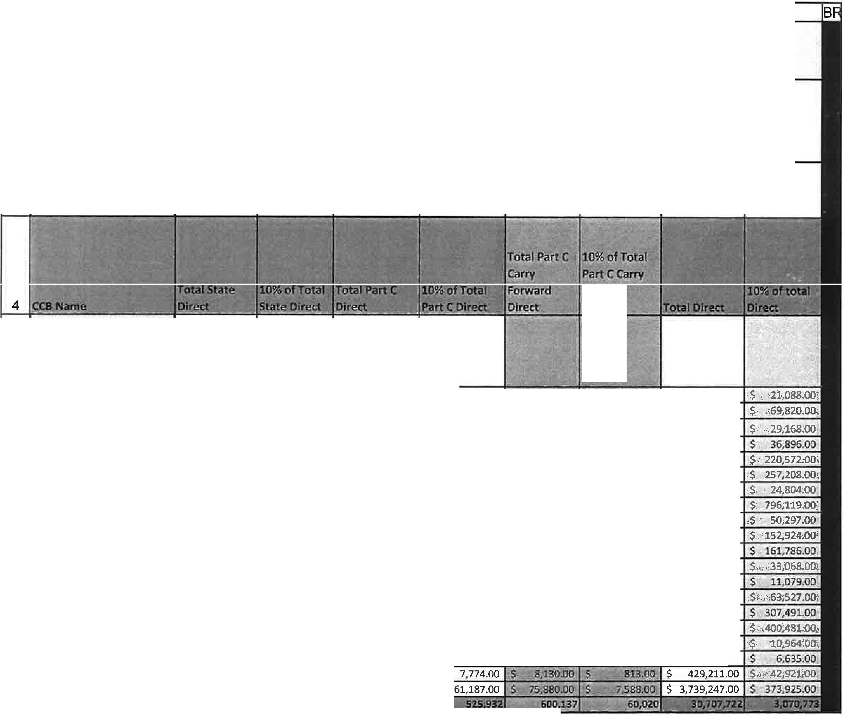A BJ BK BL BM BN BO BP BQ

Report Period Update Indirect
1

2 l7/l/14· 613Q/_J.r;

3

Forward
Dk:ect

5 Formulas
6 BLUE PEAKS $ 156 ,8 20.00 $ 15,682.00 $ 51,348.00 $ 5,135.00 '$, i! 71P.OO $ .a,7li:_f),Oi $ 210,878.00
7 COLORADO BLUESKY $ 557,458.00 $ 55,746.00 $ 125,838.00 $ 12,584.00 ' S 14:is:os.GQ .J '"l,4 op $ 698,201.00
8 COMMUNITY CONNECTIONS $ 232,126.00 $ 23,213.00 $ 52,775.00 $ 5,278.00 ;c77S.® $: '678'JiO J $ 291,676.00
9 COMMUNITY OPTIONS $ 303,928.00 $ 30,393.00 $ 60,971.00 $ 6,097.00 "S -t 5S.•_·
 | ·i!B7 J)O | $ 368,964.00
.S.. | 4,1"43.00 1 | $ 2,205,720.00
$: | 6;m 1Pa,, | $ 2,572,083.00

10 DDC/IMAGINE! $ 1,809,887.00 $ 180,989.00 $ 348,408.00 $ 34,841.00 ,S; IZ,;425.00'
·s
11 DEV. DISAB. RES. CTR $ 2,087,326.00 $ 208,733.00 s 422,427.00 $ 42,243.00 @.oo
12 DEV. OPP/STARPOINT $ 196 , 307.00 $ 19,631.00 $ 47, 665.00 s 4,767.00 :s 410!5Sl® g · 7:0(11, s 248,037.00
13 DEV. PATHWAYS $ 6,507,055.00 $ 650,706.00 $ 1,294,248.00 s 129.425.00 1S" lS9JB.!1!U> $:' f".!,5,;_ ,® $ 7,961,193.00
14 EASTERN s 385,540.00 s 38,554.00 s 105,237.00 s 10,524.00 $' - 1 95.00. 1;22tl.OO s 502,972.00
15 | ENVISION | $ 1,232,489.00 | $ 123,249.00 | $ 269,654.00 | $ 26,965.00 | . | '27,100.00. s ;.2;7:1JU!O $ 1,529,243.00
16 | FOOTHILLS-GATEWAY | $ 1,306,809.00 | $ 130,681.00 | $ 282,596.00 | $ 28,260.00 | fS, | $S·,OO $;, • •'2,84'$00 $ 1,617,860.00
17 | HORIZONS | $ 267,548.00 | $ 26,755.00 | $ 56,360.00 | $ 5,636.00 | $; | 6',775,0.Q. | ,S; . - | 618,QO | $ 330,683.00
18 | INSPIRATION FIELD | $ 83,663.00 | $ 8,366.00 | $ 25,767.00 | $ 2,577.00 | '.,S | .:i.;3SS,OO | $_-. | :1>3&,00 | $ 110,785.00

19 MOUNTAIN VALLEY $ 519,566.00 $ 51,957.00 $ 102,150.00 $ 10,215.00 :s l:3_.5SD.9l) tt< .ass,oo
20 | NORTH METRO | $ 2,433,608.00 | $ 243,361.00 | $ 561,358.00 | $ 56,136.0,0
21 | RMHS | $ 3,228,871.00 | $ 322,887.00 | $ 733,932.00 | $ 73,393.00

$ | 635,266.00
$ | 3,074,911.00
$ | 4,004,808.00

s 1..s45,o.o s·: 7,991,QQ.
.. 4'2,<)0,5 00, $;_:, ' : 4;,201.40'
22 SOUTHEASTERN $ 87,728.00 $ 8,773.00 $ 20,556.00 $ 2,056.00 '.$'', .,-1:iSS - ,i : . . _·136.00 $ 109,639.
23 SOUTHERN CO DEV SERV s 56,732.00 s 5,673.00 s 8,386.00 s 839.00 $. ·-4i,ii J.t,d' $i: _ ·., u, _s 001· $ 66,345.
24 STRIVE $ 343,344.00 s 34,334.00 s 77,737.00 s
25 TRE $ 3 , 051 , 500.00 $ 305,150.00 s 611 , 867.00 s
26 ,,i·= ; ,·.....7 1'_:_ [: ··.-;;, -·- -· ··- -

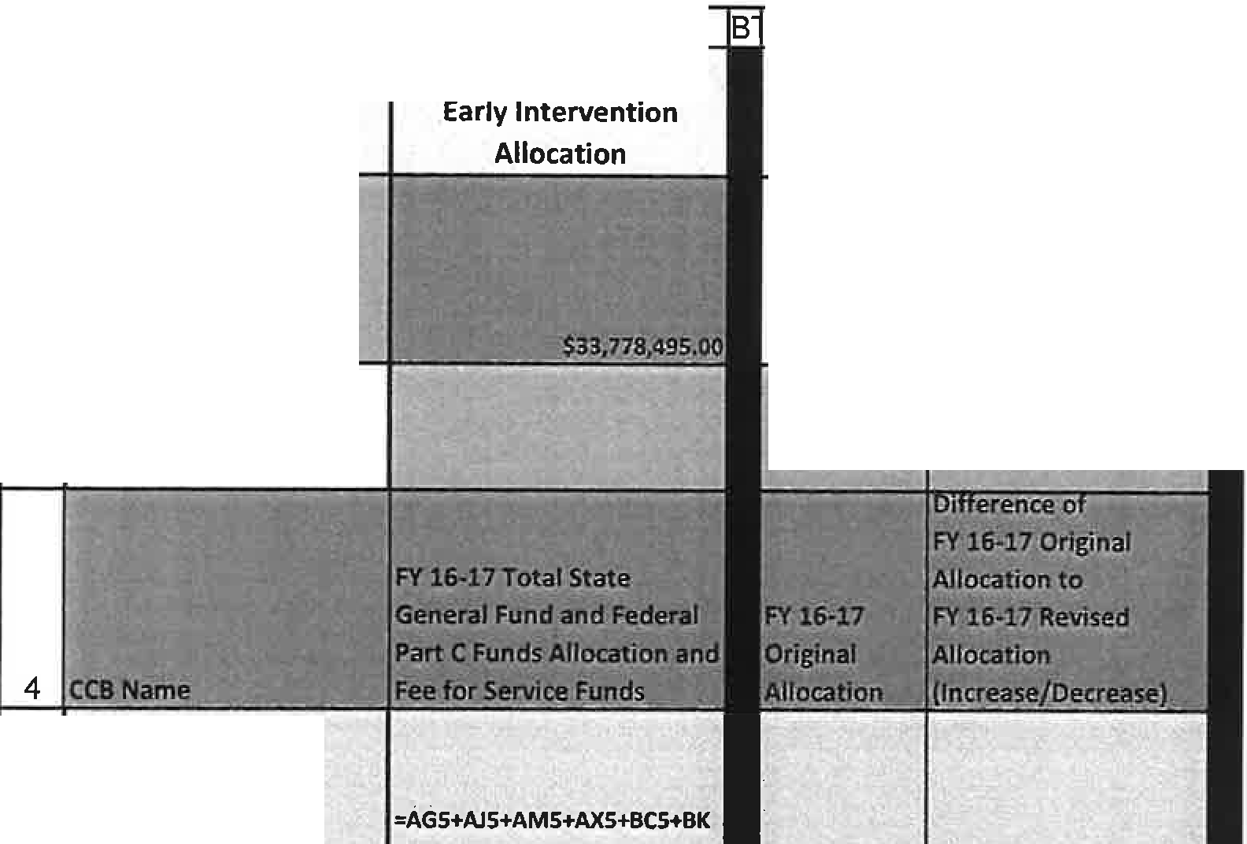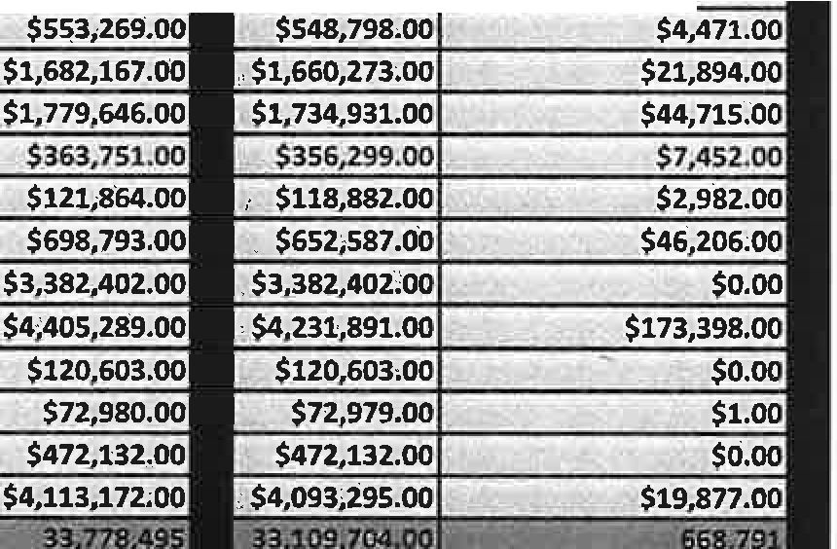FY 2016-17 Budget Allocation REVISED Exhibit B -Amendment #1
BS
Total FY 16-17 Revised
BU I
BV
IB
Report Period Update
Comparisons of Original FY16-17 Allocation to
FY16-17 Revised Allocation
2 17/l/14 J/[ 39/15
3
,= ·r,. -
A

5 | Formulas | 5 | =BF6-BH6 | $6,46:...
6 | BLUE PEAKS | $225,504.00
7 | COLORADO BLUESKY | $767,521.00 | $5
8 | COMMUNITY CONNECTIONS | $306,930.00 | $13,914.00
 | COMMUNITY OPTIONS | $404,370.00 | $1,490.00
10 | DOC/IMAGINE! | . $2;335,371.00 | $90,921.00
11 | DEV. DISAB. RES. CTR | . $2,699,618.00 | $129,673.00
12 | DEV. OPP/STARPOINT | $272,841.00 $261,907.00 | $10,934.00
13 | DEV. PATHWAYS | $8,757,312.00 $8,663,411.00 |  | $93,901,00
14 | EASTERN  ENVISION  FOOTHILLS-GATEWAY | c:-cr:::;; . -a, -- -- - - -£- -, = ·
15
16
17 | HORIZONS  INSPIRATION FIELD
18
19 | MOUNTAIN VALLEY
20 | NORTH METRO RMHS SOUTHEASTER  SOUTHERN CO DEV SERV STRIVE  TRE
21
22
23
24
25
26 I

Page 8 of 8 Revised March 14, 2017
.
I

Exhibit F - Amendment #1

Colorado Department of Human Services Office of Early Childhood

BUDGET WITH JUSTIFICATION FORM
Contractor Name | Southern Colorado Developmental Disabilities Services, Inc.
Budget Period | July 2016 - June 2017
Project Name | Early Intervention

Program Contact Name, Title, Phone and Email | Duane Roy, CEO  719-846-4409  droy@scds.com
Fiscal Contact Name, Title, Phone and Email | Mary Beach, CFO  719-846-3391 X 101  marybeach@scdds.com

.,,.,
,,,
;' --
enditure Categories - . -,, ,' ,.._,-., r:-, ··-
-:::) - J" i f FY 2017
;:;
E>,<p"
---

State General Funds Service Coordination
-
- ,_ ·- '

Description of Work Funding Amount
.·-
Paid as fixed price at rate of 1/12 per month, Provide Service Coordination activities including working with families from initial referral through evaluation; to ensure the IFSP is completed; help navigate the system for early intervention services for the duration of the open case
file; specific details for service coordination can be found in Exhibits A and B. $9,485
- - FY 2017
- -
- | State G.eneral Fund - Direct Services _,

Description of Work Funding Amount
Paid as fee for service. The Early Intervention Program shall design services to meet the developmental needs of an eligible infant or toddler and the needs of his or her family related to functional outcomes to enhance the child's development in the domains of adaptive development, cognitive development, communication development, physical development (including vision and hearing). and, social emotional development. Direct Services include, not limited to, speech therapist, occupational therapist, mental health consultation, other

disciplines that work directly with the client as defined in Exhibits A and B.
State General Fund - Operations
.. $44,260
. FY 2017
.,

Descript ion of Work Funding Amount
Paid as fixed price at rate of 1/12 per month for infrastructure, administration and other services as defined in Exhibits A & B. $2,987
State General Fund - Indirect (i0%) " - FY2017
Description of Work Funding Amount
Indirect costs calculated at 10% of total direct costs . $5, 673

Federal Part C Funds - Direct Services
. I' - . -
', FY 2017

Description of Work Funding Amount
Paid as fee for service. The Early Intervention Program shall design services to meet the developmental needs of an eligible infant or toddler and the needs of his or her family related to functional outcomes to enhance the child's development in the domains of adaptive development, cognitive development, communication development, physical development (including vision and hearing), and, social emotional development. Direct Services include, not limited to, speech therapist, occupational therapist, mental health consultation, other

disciplines that work directly with the client as defined in Exhibits A and B.
Federal Part C Funds - Operations
,, -- - ,.
- - -
-
$4, 426
FY 2017

Description of Work Funding Amount
Paid as fixed price at rate of 1/12 per month for infrastructure, administration and other services as defined in Exhibits A & B. $1,586
Federal Part C Funds- l odired .(10%) - FY 2017
- -
Description of Work Funding Amount

Indirect costs calculated at 10% of total direct costs.
Federal Part C Funds Carry Forward- Indirect (10%)
- .. - --.

FY 2017
$826

Description of Work funding Amount
Indirect costs calculated at 10% of total direct costs. $136
Federal Part C Funds - Service Coordination "· - - •. FY 2017
Description of Work Funding Amount
Paid as fixed price at rate of 1/12 per month. Provide Service Coordination activities including working with families from initial referral through evaluation; to ensure the IFSP is completed; help navigate the system for early intervention services for the duration of the open case
file; specific details for service coordination can be found in Exhibits A and B. $1,251
Federal Part C Funds Carry Forward - Service Coordination '!: - t FY 2017
Description of Work Funding Amount
Paid as fixed price at rate of 1/12 per month. Provide Service Coordination activities including working with families from initial referral through evaluation; to ensure the IFSP is completed; help navigate the system for early intervention services for the duration of the open case
file; specific details for service coordination can be found in Exhibits A and B. $1,227

Exhibit F - Amendment #1

 | - Federal Part C Funds • Referred Evalu ted Not Eligible (RE E) - --· -  Description of Work |  | FY 2017
 |  |  | Funding Amount
Paid as fixed price. Reimbursement for costs related to evaluation services for ellglb lllty determination for Infants, toddlers or families referred for early Intervention services that are determ ined not eligible. |  |  | $1,123
r TPTAL ·'  -, |  |  | - :.} 72,9]10
*Figures are rounded using basic accounting standards . (0.00·0.49 = D; 0.50 -0.99=1.0)

EXHIBIT H -Amendment #1 - Supplemental Provisions for Federal Awards

For the purposes of this Exhibit only, Contractor is also identified as "Subrecipient." This Contract has been funded, in whole or in part, with an award of Federal funds. In the event of a conflict between the provisions of these Supplemental Provisions for Federal Awards, the Special Provisions, the Contract or any attachments or exhibits incorporated into and made a part of the Contract, the Supplemental Provisions for Federal Awards shall control. In the event of a conflict between the Supplemental Provisions for Federal Awards and the FFATA Supplemental Provisions (if any), the FFATA Supplemental Provisions shall control.

- Federal Award Identification

1.
11.
111.
lV.
v.
Vl.

VU.
Vlll.

lX.

Subrecipient: Southern Colorado Developmental Disabilities Services, Inc.;
Subrecipient DUNS number: 182458059;
The Federal Award Identification Number (FAIN) is Hl81Al50097; H181A160097;
The Federal award date is H181A150097 - July 1, 2015; H181Al60097 - July 1, 2016;
The subaward period of performance start date is July 1, 2016 and end date is June 30, 2017;
Federal Funds:

Contract or Fiscal Year | Amount of Federal funds obligated by this Contract | Total amount of Federal funds obligated to the  Subrecipient | Total amount of the  Federal Award committed to Subrecioient bv CDHS
FY17 | $10,575 | $10,575 | H181Al50097 - $1,363  H181A160097 - $9.212
Federal award project description: 84.181A Infants and Toddlers with Disabilities;
The name of the Federal awarding agency is United States Department of Education; the name of the pass­ through entity is the State of Colorado, Department of Human Services (CDHS); and the contact information for the awarding official is Mary Martin, Director, Division for Community and Family Support, 1575 Sherman Street, 1st Floor, Denver, CO 80203; maryw.martin@state.co.us; 303-866-5023;
The Catalog of Federal Domestic Assistance (CFDA) number is 84.181A, name is Special Education -
Grants for Infants and Families with Disabilities, and dollar amount is $10,575;

x. This award is not for research & development;
x1. The indirect cost rate for the Federal award (including if the de minimis rate is charged per 2 CFR §200.414 Indirect (F&A) costs) is pre-determined based upon the State of Colorado and CDHS cost allocation plan.
- All requirements imposed by CDHS on Subrecipient so that the Federal award is used in accordance with Federal statutes, regulations, and the terms and conditions of the Federal award, are stated in the General Provisions, Exhibit A- Statement of Work for Early Intervention Services and Exhibit I -Additional Provisions.
- Any additional requirements that CDHS imposes on Subrecipient in order for CDHS to meet its own responsibility to the Federal awarding agency, including identification of any required financial and performance reports, are stated in the General Provisions, Exhibit A - Statement of Work for Early Intervention Services and Exhibit I - Additional Provisions.
- Subrecipient's approved indirect cost rate is Ute de minimi rate o 10 %.
- Subrecipient must permit CDHS and auditors to have access to Subrecipient's records and financial statements as necessary for CDHS to meet the requirements of2 CFR §200.331 Requirements for pass-through entities,§§ 200.300 Statutory and National Policy Requirements through §200.309 Period of performance, and Subpart F-Audit Requirements of this Part.
- The appropriate terms and conditions concerning closeout of the subaward are listed in Section 16 of this Exhibit and the General Provisions, Exhibit A - Statement of Work for Early Intervention Services and Exhibit I - Additional Provisions.

- Performance and Final Status. Subrecipient shall submit all financial, performance, and other reports to CDHS no later than 30 calendar days after the period of performance end date or sooner termination of this Contract containing an evaluation and review of Subrecipient's performance and the final status of Subrecipient's obligations hereunder.

Matching Funds
If a box below is checked, the accompanying provision applies.

1. li'.'.'.J Subrecipient is not required to provide matching funds.
ii. D Subrecipient shall prov;ide matching funds as stated in n/a. Subrecipient shall have rai ed the full amount of matching funds prior to the Effective Date and shall report to CDHS regarding the status of such funds upon request. Subrecipient' s obligation to pay all or any part of any matching funds, whether direct or contingent, only extends to funds duly and lawfully appropriated for the purposes of this Contract by the authorized representatives of the Subrecipient and paid into the Subrecipient' s treasury or bank account. Subrecipient represents to CDHS that the amount designated as matching funds has been legally appropriated for the purposes of this Contract by its authorized representatives and paid into its treasury or bank account. Subrecipient does not by this Contract irrevocably pledge present cash reserves for payments in future fiscal years, and this Contract is not intended to create a multiple-fiscal year debt of the Subrecipient. Subrecipient shall not pay or be liable for any claimed interest, late charges, fees, taxes or penalties of any nature, except as required by Subrecipient's laws or policies.
- Record Retention Period. The record retention period previously stated in this Contract is replaced with the record retention period prescribed in 2 CPR §200.333.
IO) Single Audit Requirements. If Subrecipient expends $750,000 or more in Federal Awards during Subrecipient's fiscal year, Subrecipient shall procure or arrange for a single or program-specific audit conducted for that year in accordance with the provisions of Subpart F-Audit Requirements of the Uniform Guidance, issued pursuant to the Single Audit Act Amendments of 1996, (31 U.S.C. 7501-7507). 2 CFR §200.501.
  - Election. Subrecipient shall have a single audit conducted in accordance with Uniform Guidance §200.514 (Scope of audit), except when it elects to have a program-specific audit conducted in accordance with
§200.507 (Program-specific audits). Subrecipient may elect to have a program-specific audit if Subrecipient expends Federal Awards under only one Federal program (excluding research and development) and the Federal program's statutes, regulations, or the terms and conditions of the Federal award do not require a financial statement audit of CDHS. A program-specific audit may not be elected for research and development unless all of the Federal Awards expended were received from CDHS and CDHS approves in advance a program-specific audit.
11. Exemption. If Subrecipient expends less than $750,000 in Federal Awards during its fiscal year, Subrecipient shall be exempt from Federal audit requirements for that year, except as noted in 2 CFR §200.503 (Relation to other audit requirements), but records shall be available for review or audit by appropriate officials of the Federal agency, the State, and the Government Accountability Office.
iii. Subrecipient Compliance Responsibility. Subrecipient shall procure or otherwise arrange for the audit required by Part F of the Uniform Guidance and ensure it is properly performed and submitted when due in accordance with the Uniform Guidance. Subrecipient shall prepare appropriate financial statements, including the schedule of expenditures of Federal awards in accordance with Uniform Guidance §200.510 (Financial statements) and provide the auditor with access to personnel, accounts, books, records, supporting documentation, and other information as needed for the auditor to perform the audit required by 2 CFR Part F-Audit Requirements.
- Contract Provisions. Subrecipient shall comply with and shall include all of the following applicable provisions in all subcontracts entered into by it pursuant to this Contract:
1. Equal Employment Opportunity. Except as otherwise provided under 41 CPR Part 60, all contracts that meet the definition of "federally assisted construction contract" in 41 CFR Part 60-1.3 shall include the equal

opportunity clause provided under 41 CFR 60-l.4(b), in accordance with Executive Order 11246, "Equal Employment Opportunity" (30 FR 12319, 12935, 3 CFR Part, 1964-1965 Comp., p. 339), as amended by Executive Order 11375, "Amending Executive Order 11246 Relating to Equal Employment Opportunity," and implementing regulations at 41 CFR part 60, "Office of Federal Contract Compliance Programs, Equal Employment Opportunity, Department of Labor."

"During the performance of this contract, the contractor agrees as follows:
  - The contractor will not discriminate against any employee or applicant for employment because of race, color, religion, sex, or national origin. The contractor will take affirmative action to ensure that applicants are employed, and that employees are treated during employment, without regard to their race, color, religion, sex, or national origin. Such action shall include, but not be limited to the following: Employment, upgrading, demotion, or transfer, recruitment or recruitment advertising; layoff or termination; rates of pay or other forms of compensation; and selection for training, including apprenticeship. The contractor agrees to post in conspicuous places, available to employees and applicants for employment, notices to be provided by the contracting officer setting forth the provisions of this nondiscrimination clause.
  - The contractor will, in all solicitations or advertisements for employees placed by or on behalf of the contractor, state that all qualified applicants will receive consideration for employment without regard to race, color, religion, sex, or national origin.
  - The contractor will send to each labor union or representative of workers with which he has a collective bargaining agreement or other contract or understanding, a notice to be provided by the agency contracting officer, advising the labor union or workers' representative of the contractor's commitments under section 202 of Executive Order 11246 of September 24, 1965, and shall post copies of the notice in conspicuous places available to employees and applicants for employment.
  - The contractor will comply with all provisions of Executive Order 11246 of September 24, 1965, and of the rules, regulations, and relevant orders of the Secretary of Labor.
  - The contractor will furnish all information and reports required by Executive Order 11246 of September 24, 1965, and by the rules, regulations, and orders of the Secretary of Labor, or pursuant thereto, and will permit access to his books, records, and accounts by the contracting agency and the Secretary of Labor for purposes of investigation to ascertain compliance with such rules, regulations, and orders.
  - In the event of the contractor's non-compliance with the nondiscrimination clauses of this contract or with any of such rules, regulations, or orders, this contract may be canceled, terminated or suspended in whole or in part and the contractor may be declared ineligible for further Government contracts in accordance with procedures authorized in Executive Order 11246 of September 24, 1965, and such other sanctions may be imposed and remedies invoked as provided in Executive Order 11246 of September 24, 1965, or by rule, regulation, or order of the Secretary of Labor, or as otherwise provided by law.
  - The contractor will include the provisions of paragraphs (1) through (7) in every subcontract or purchase order unless exempted by rules, regulations, or orders of the Secretary of Labor issued pursuant to section 204 of Executive Order 11246 of September 24, 1965, so that such provisions will be binding upon each subcontractor or vendor. The contractor will take such action with respect to any subcontract or purchase order as may be directed by the Secretary of Labor as a means of enforcing such provisions including sanctions for noncompliance: Provided, however, that in the event the contractor becomes involved in, or is threatened with, litigation with a subcontractor or vendor as a result of such direction, the contractor may request the United States to enter into such litigation to protect the interests of the United States."

4.2 Davis-Bacon Act. Davis-Bacon Act, as amended (40 U.S.C. 3141-3148). When required by Federal program legislation, all prime construction contracts in excess of $2,000 awarded by non-Federal entities must include a provision for compliance with the Davis-Bacon Act (40 U.S.C. 3141-3144, and 3146-3148) as supplemented by Department of Labor regulations (29 CFR Part 5, "Labor Standards Provisions Applicable to Contracts Covering Federally Financed and Assisted Construction"). In accordance with the statute, contractors must be required to pay wages to laborers and mechanics at a rate not less than the prevailing wages specified in a wage determination made by the Secretary of Labor. In addition, contractors must be required to pay wages not less than once a week. The non-Federal entity must place a copy of the current prevailing wage determination issued by the Department of Labor in each solicitation. The decision to award a contract or subcontract must be conditioned upon the acceptance of the wage determination. The non­ Federal entity must report all suspected or reported violations to the Federal awarding agency. The contracts must also include a provision for compliance with the Copeland "Anti-Kickback" Act (40 U.S.C. 3145), as
supplemented by Department of Labor regulations (29 CFR Part 3, "Contractors and Subcontractors on Public Building or Public Work Financed in Whole or in Part by Loans or Grants from the United States"). The Act provides that each contractor or Subrecipient must be prohibited from inducing, by any means, any person employed in the construction, completion, or repair of public work, to give up any part of the compensation to which he or she is otherwise entitled. The non-Federal entity must report all suspected or reported violations to the Federal awarding agency.
- Rights to Inventions Made Under a Contract or Agreement. If the Federal Award meets the definition of "funding agreement" under 37 CFR §401.2 (a) and Subrecipient wishes to enter into a contract with a small business firm or nonprofit organization regarding the substitution of parties, assignment or performance of experimental, developmental, or research work under that "funding agreement," Subrecipient must comply with the requirements of 37 CFR Part 401, "Rights to Inventions Made by Nonprofit Organizations and Small Business Firms Under Government Grants, Contracts and Cooperative Agreements," and any implementing regulations issued by the awarding agency.
1v. Clean Air Act (42 U.S.C. 7401-7671q.) and the Federal Water Pollution Control Act (33 U.S.C. 1251-1387), as amended. Contracts and subgrants of amounts in excess of $150,000 must contain a provision that requires the non-Federal award to agree to comply with all applicable standards, orders or regulations issued pursuant to the Clean Air Act (42 U.S.C. 7401-7671q) and the Federal Water Pollution Control Act as amended (33
U.S.C. 1251-1387). Violations must be reported to the Federal awarding agency and the Regional Office of the Environmental Protection Agency (EPA).
v. Debarment and Suspension (Executive Orders 12549 and 12689). A contract award (see 2 CPR 180.220) must not be made to parties listed on the government wide exclusions in the System for Award Management (SAM), in accordance with the 0MB guidelines at 2 CFR 180 that implement Executive Orders 12549 (3 CFR part 1986 Comp., p. 189) and 12689 (3 CPR part 1989 Comp., p. 235), "Debarment and Suspension." SAM Exclusions contains the names of parties debarred, suspended, or otherwise excluded by agencies, as well as parties declared ineligible under statutory or regulatory authority other than Executive Order 12549.
v1. Byrd Anti-Lobbying Amendment (31 U.S.C. 1352). Contractors that apply or bid for an award exceeding
$100,000 must file the required certification. Each tier certifies to the tier above that it will not and has not used Federal appropriated funds to pay any person or organization for influencing or attempting to influence an officer or employee of any agency, a member of Congress, officer or employee of Congress, or an employee of a member of Congress in connection with obtaining any Federal contract, grant or any other award covered by 31 U.S.C.1352. Each tier must also disclose any lobbying with non-Federal funds that takes place in connection with obtaining any Federal award. Such disclosures are forwarded from tier to tier up to the non-Federal award.
- Compliance. Subrecipient shall comply with all applicable provisions of The Office of Management and Budget Uniform Administrative Requirements, Cost Principles, and Audit Requirements for Federal Awards (Uniform

Guidance), including but not limited to these Supplemental Provisions for Federal Awards. Any revisions to such provisions automatically shall become a part of these Supplemental Provisions, without the necessity of either party executing any further instrument. CDHS may provide written notification to Subrecipient of such revisions, but such notice shall not be a condition precedent to the effectiveness of such revisions.
- Procurement Procedures. Subrecipient shall use its own documented procurement procedures which reflect applicable State, local, and Tribal laws and regulations, provided that the procurements conform to applicable Federal law and the standards identified in the Uniform Guidance, including without limitation, §§200.318 through 200.326 thereof.
- Certifications. Unless prohibited by Federal statutes or regulations, CDHS may require Subrecipient to submit certtfications and representations required by Federal statutes or regulations on an annual basis (2 CFR §200.208). Submission may be required more frequently if Subrecipient fails to meet a requirement of the Federal award. Subrecipient shall certify in writing to CDHS at the end of the Contract that the project or activity was completed or the level of effort was expended. 2 CFR §200.201(b)(3). If the required level of activity or effort was not carried out, the amount of the Contract must be adjusted.
- Event of Default. Failure to comply with the Uniform Guidance or these Supplemental Provisions for Federal Awards shall constitute an event of default under the Contract pursuant to 2 CFR §200.339 and CDHS may terminate the Contract in accordance with the termination provisions in the Contract.
- Close Out. Subrecipient shall close out this Contract within 90 days after the End Date. Contract close out entails submission to CDHS by Subrecipient of all documentation defined as a deliverable in this Contract, and Subrecipient's final reimbursement request. CDHS shall withhold 5% of the allowable costs until all final project documentation has been submitted and accepted by State as substantially complete. If the project has not been closed by the Federal awarding agency within 1 year and 90 days after the End Date due to Subrecipient's failure to submit required documentation that CDHS has requested from Subrecipient, then Subrecipient may be prohibited from applying for new Federal awards through the State until such documentation has been submitted and accepted.
- Erroneous Payments. The closeout of a Federal award does not affect the right of the Federal awarding agency or CDHS to disallow costs and recover funds on the basis of a later audit or other review. Any cost disallowance recovery is to be made within the record retention period.

EXHIBIT END

Exhibit I

- SUPPLANTING

Payments made to the Contractor under this contract will supplement and not supplant other state, local or federal expenditures for services associated with this contract.

- BUDGET CHANGES
Changes to the Budget, EXHIBITS B and F of this contract, shall be made only with the prior written approval by the State in the form of a budget revision, contract amendment or option letter as applicable. Any changes to the Budget shall not exceed the total amount of the contract as described on page one of the contract.

- RIGHTS IN DATA, DOCUMENTS, AND COMPUTER SOFTWARE
Any software, research, reports, studies, data, photographs, negatives or other documents,
drawings, models, materials, or work product of any type, including drafts, prepared by Contractor in the performance of its obligations under this Contract shall be the exclusive property of the State, and all Work Product shall be delivered to the State by Contractor upon completion, by request, or termination hereof.
This ownership implies that OEC has full control of these data, reports and analyses, as well as full access to these data, report and analyses. Control implies full and complete control as to how any and all data, records, analyses and reports produced as part of this contract are used. Access implies full and complete access to any and all data, records, analyses and reports produced as part of this contract. Upon request by OEC at any time and from time to time and without regard to the default status of the parties under this contract, the contractor and/or its subcontractors shall promptly deliver to OEC the all existing data, records, analyses and reports in electronic format and in such hard copy as exists on the date of the request by OEC.

The State's exclusive rights in such work product shall include, but not be limited to, the right to copy, publish, display, transfer, and prepare derivative works. Contractor shall not use, willingly allow, cause or permit such work product to be used for any purpose other than the performance of Contractor's obligations hereunder without the prior written approval of the State.

Page2of2

